1. **Write a Lex Program to remove comments from C program.**

%{  
#include<stdio.h>  
%}  
%%  
"//"([a-z]|[0-9]|[A-Z]|" ")*    {}  
"/"([a-z]|[0-9]|[A-Z]|" "\""\n")+"/"    {}  
%%  
int main()  
{  
yylex();  
return 0;  
}  
int yywrap()  
{  
}

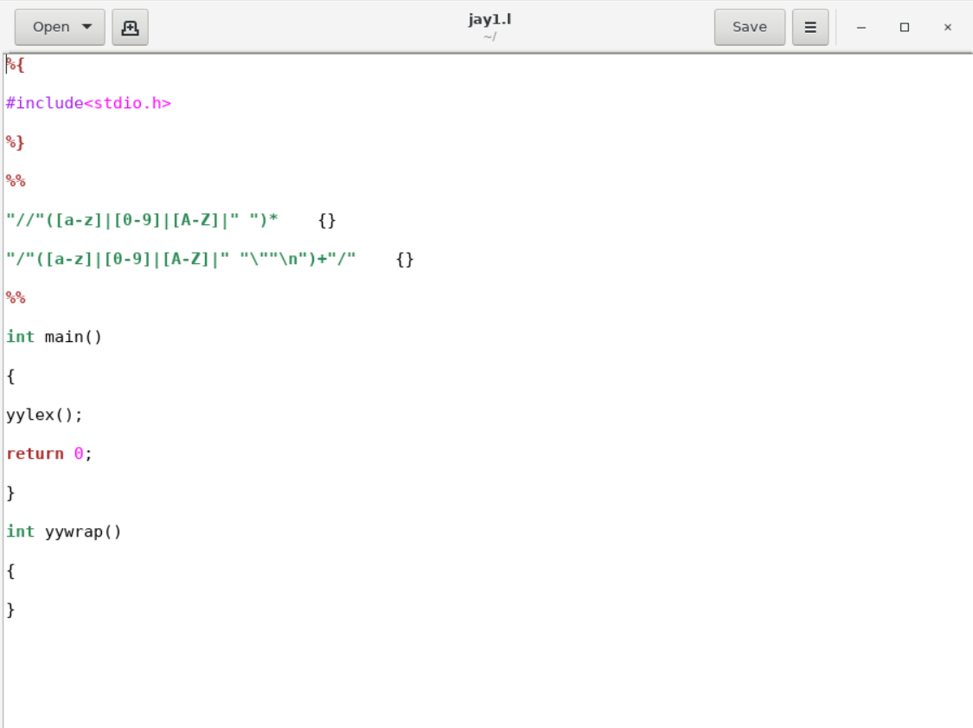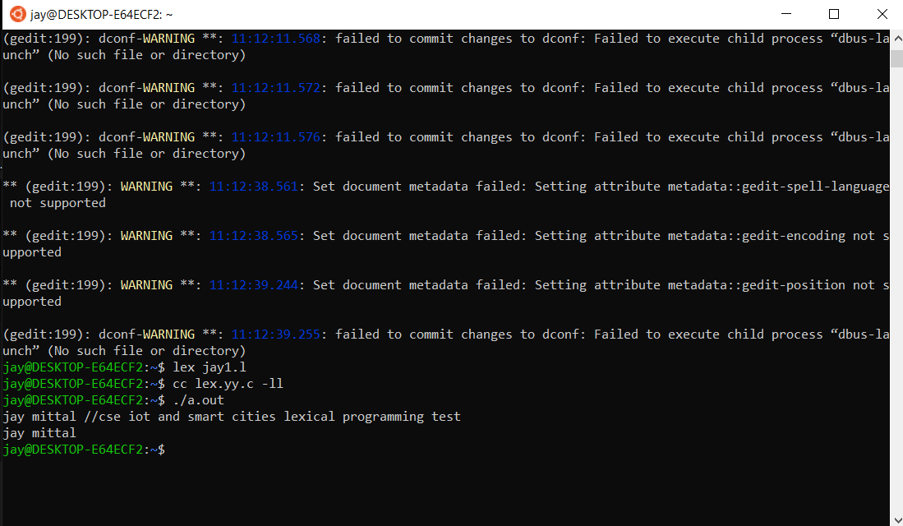

1. **Write a Lex Program to check valid emails.**

%{

#include<stdio.h>

#include<stdlib.h>

int flag=0;

%}

%%

[a-z . 0-9]+@[a-z]+".com"|".in" { flag=1; }

%%

int main()

{

yylex();

if(flag==1)

printf("Accepted");

else

printf("Not Accepted");

}

